**UBER EXPEDITIONARY ANALYSIS**

**PROJECT REPORT**

* **INTRODUCTION:**
* Overview:
* In the ever-evolving landscape of transportation and technology, Uber, the global ride-hailing giant, has embarked on an ambitious expedition into the world of autonomous vehicles. This journey, aptly named "Voyage Vista," represents a pioneering foray into the future of mobility. Autonomous vehicles hold the promise of revolutionizing the way we move, offering safer, more efficient, and environmentally conscious alternatives to traditional transportation methods. However, this bold venture is not without its challenges. In this analysis, we delve into the multifaceted terrain of Uber's expeditionary efforts, exploring the significant problems encountered and the strategic solutions employed to navigate them. From technical hurdles to regulatory complexities and the imperative quest for public acceptance, the journey of Uber's Voyage Vista offers a compelling case study in the pursuit of an autonomous future. This examination seeks to shed light on the pivotal questions surrounding this endeavor and uncover the strategies and innovations shaping the path forward.

PURPOSE:

1. **Understanding Industry Evolution:** To gain insight into the changing landscape of the transportation and technology industry and how Uber is positioning itself within this transformation.
2. **Problem Identification:** To identify and evaluate the key challenges and obstacles Uber faces in its expeditionary analysis, allowing for a comprehensive understanding of the project's complexities.
3. **Solutions Assessment:** To assess the strategies and solutions Uber employs to address these challenges, providing valuable insights for businesses and stakeholders in the autonomous vehicle sector.
4. **Safety and Regulatory Considerations:** To explore the safety and regulatory aspects of autonomous vehicles, which are paramount for the success of Uber's project and the industry at large.
5. **Market and Public Perception:** To investigate the public's perception and acceptance of autonomous technology, which is essential for widespread adoption and success in the market.
6. **Economic Implications:** To analyze the economic impact of Uber's autonomous vehicle efforts, including cost management, revenue models, and financial sustainability.

* **PROBLEM DEFINITION & DESIGN THINKING:**

* EMPATHY MAP:

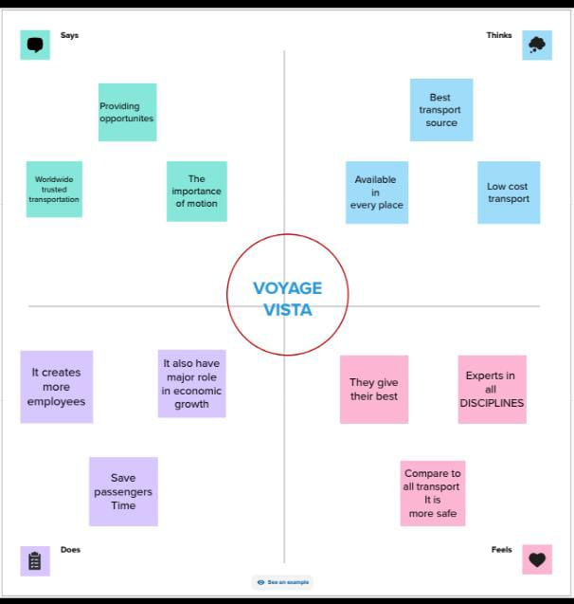

* BRAINSTORMING MAP:

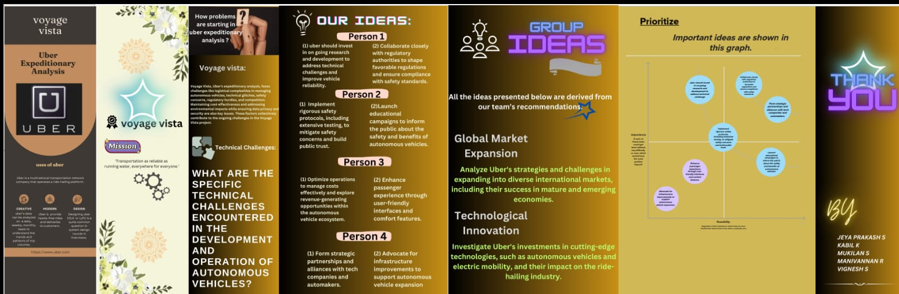

* **RESULT:**
* **Screen shots:**

**Dashboard 1**

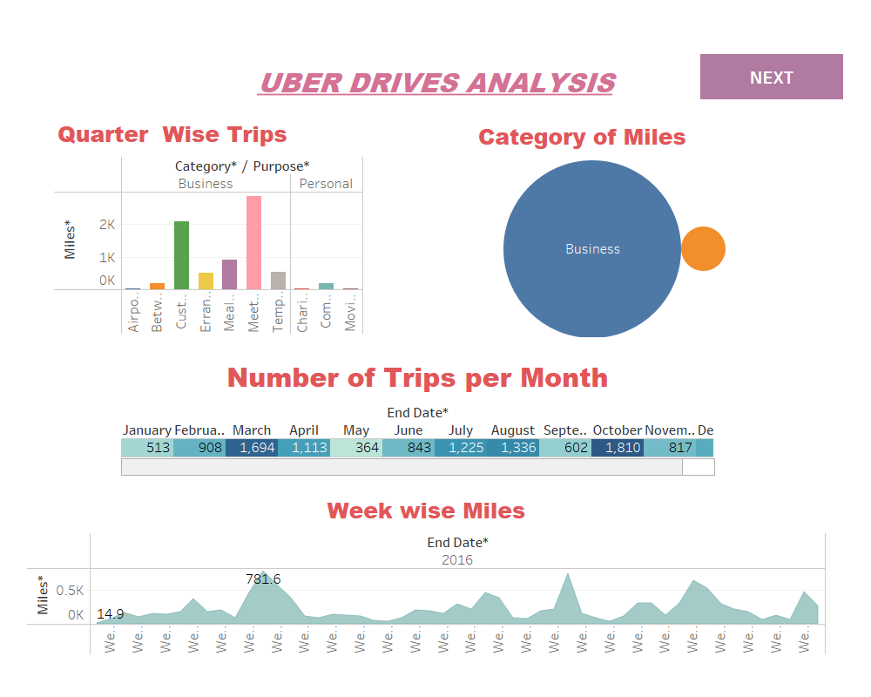

Dashboard 2

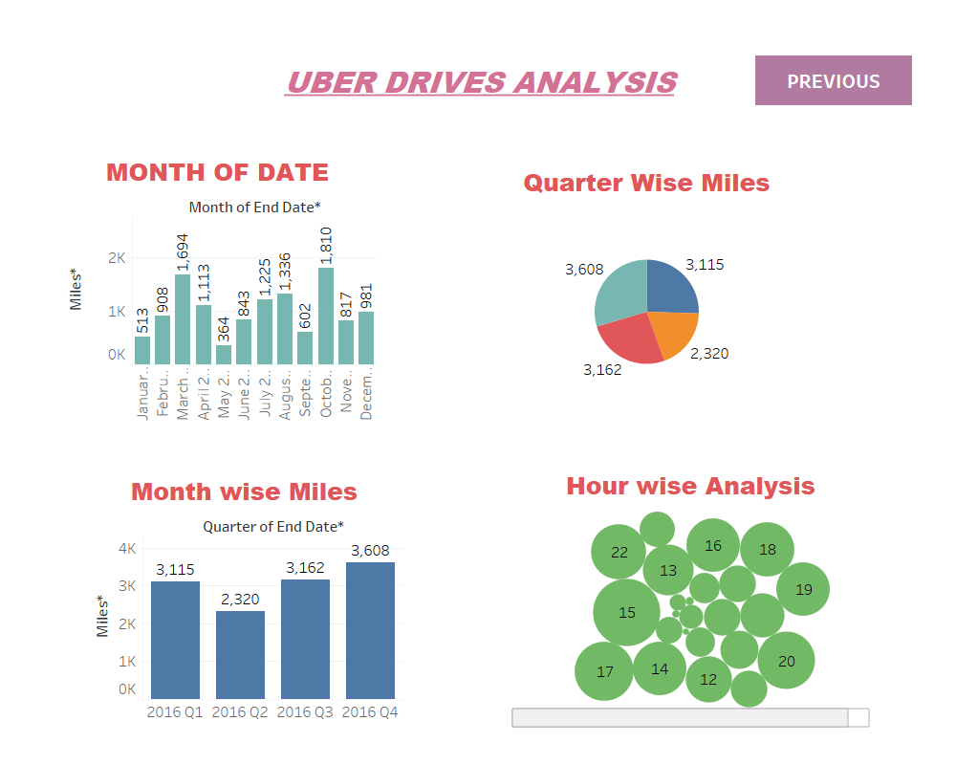

**STORY**

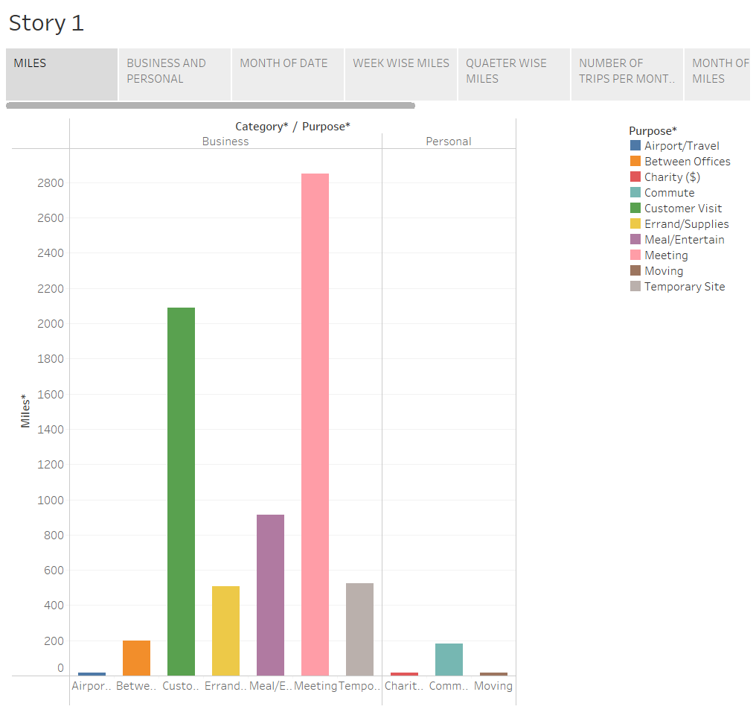

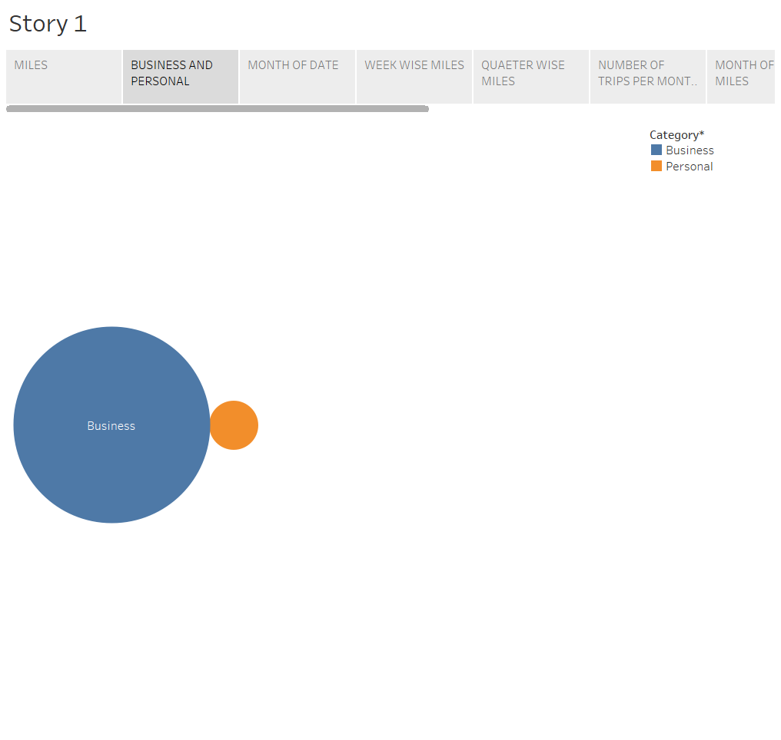

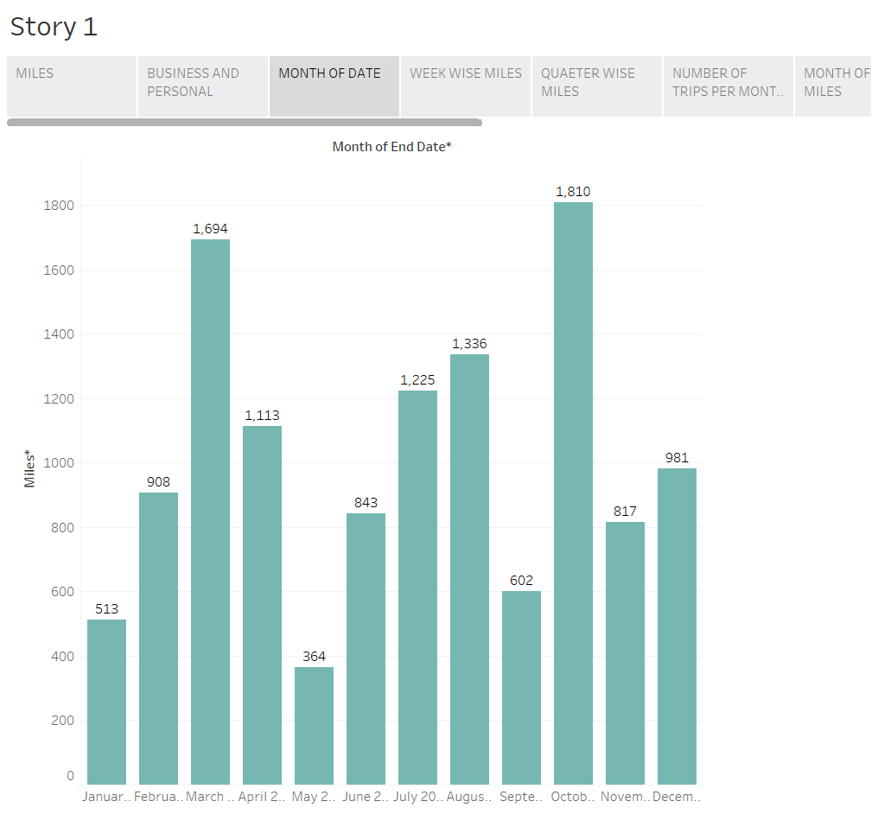

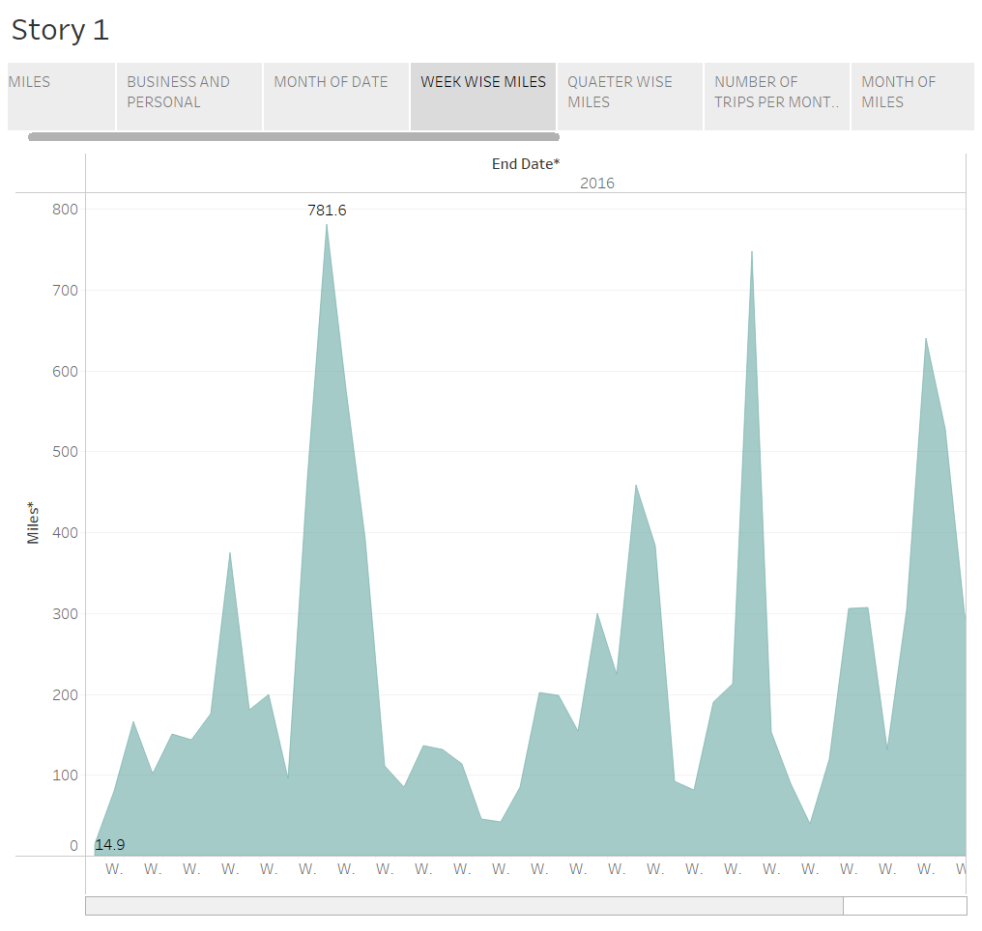

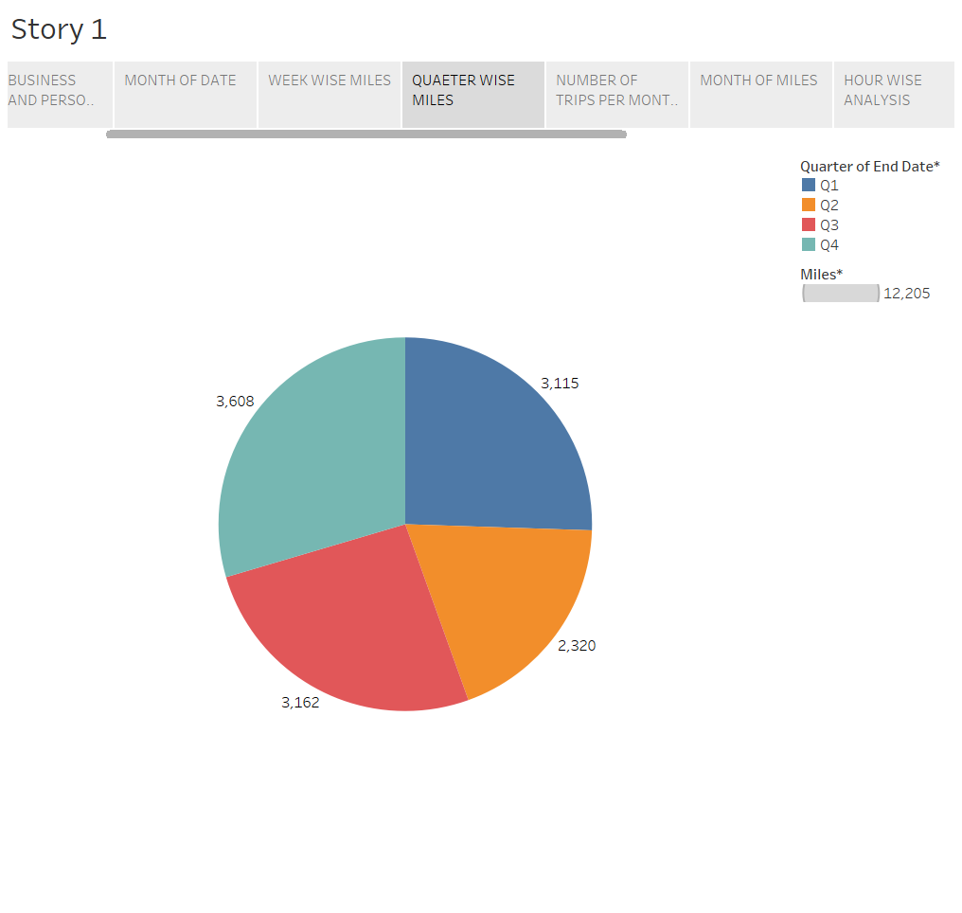



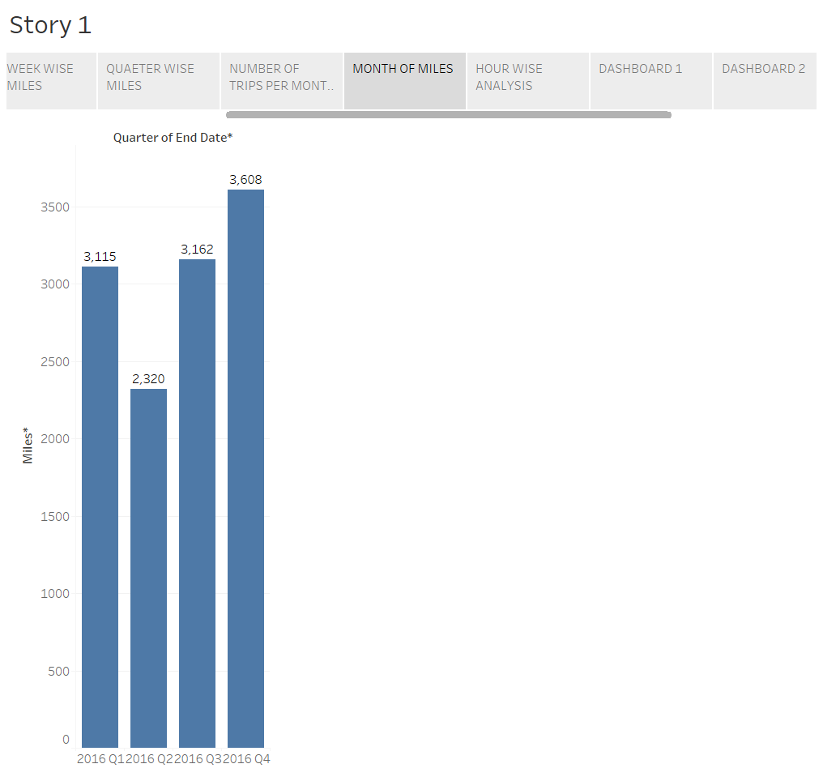

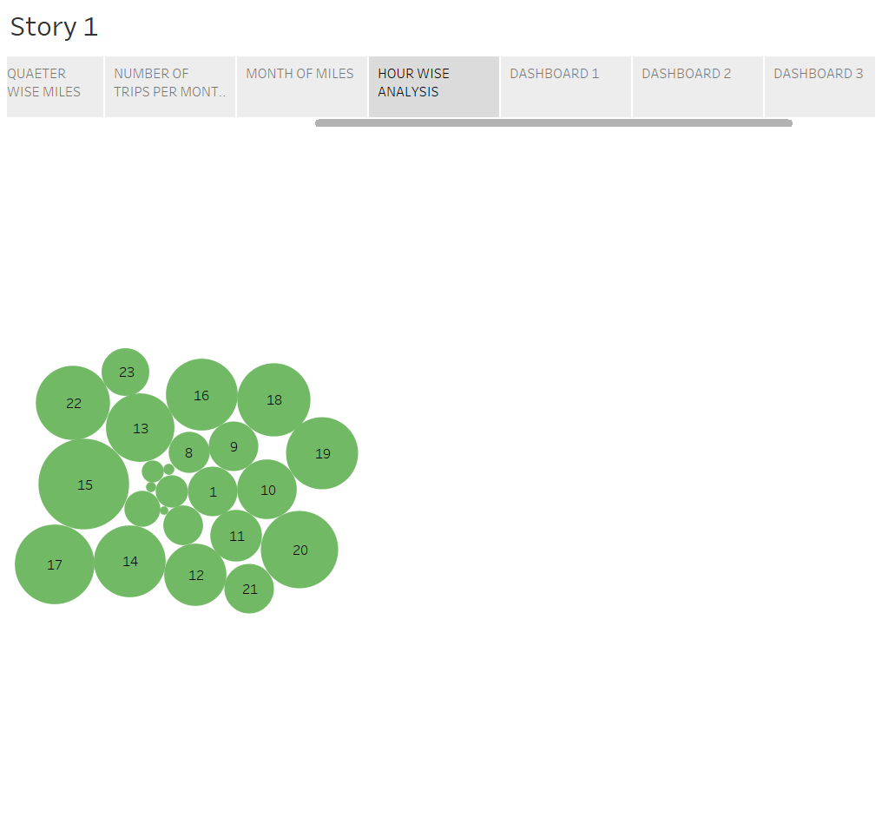

* **ADVANDAGES & DISADVANDAGES:**

The advantages of Uber's expeditionary efforts in the realm of autonomous vehicles, such as the "Voyage Vista" project, are multifaceted and extend to various aspects of the transportation and technology industry:

1. **Safety Improvements:** Autonomous vehicles have the potential to significantly reduce accidents caused by human error, leading to safer roads and fewer injuries.
2. **Efficiency and Productivity:** Autonomous vehicles can operate 24/7, potentially reducing traffic congestion and increasing overall transportation efficiency.
3. **Reduced Operating Costs:** With autonomous vehicles, Uber can potentially reduce labor costs, fuel expenses, and maintenance, making transportation more cost-effective.
4. **Environmental Benefits:** The adoption of electric autonomous vehicles can lead to a decrease in emissions and a more sustainable transportation system.
5. **Enhanced Accessibility:** Autonomous vehicles can offer more accessible transportation options for people with disabilities, the elderly, and those who cannot drive.
6. **Improved User Experience:** Passengers can enjoy a more convenient and personalized transportation experience with autonomous vehicles.
7. **Data-Driven Insights:** The data generated by autonomous vehicles can provide valuable insights for urban planning, traffic management, and business operations.
8. **Economic Growth:** The development and deployment of autonomous technology can stimulate economic growth through job creation and increased innovation.
9. **Technical Challenges:** Developing and maintaining autonomous vehicles involves complex technology, and technical glitches or failures can disrupt operations.
10. **Safety Concerns:** Despite safety protocols, accidents and system failures can occur, raising questions about the safety of autonomous vehicles.
11. **Regulatory Hurdles:** Navigating evolving and sometimes inconsistent regulations for autonomous vehicles can lead to delays and complications.
12. **Public Skepticism:** Many people are apprehensive about the safety and ethics of autonomous vehicles, which can hinder public acceptance.
13. **Operational Costs:** The upfront costs of developing and maintaining autonomous vehicles can be substantial, affecting profitability.
14. **Labor Displacement:** The shift to autonomous vehicles may lead to job displacement for human drivers, impacting livelihoods and communities.
15. **Data Privacy and Security:** Autonomous vehicles collect vast amounts of data, raising concerns about privacy and the risk of data breaches.
16. **Environmental Impact:** While electric autonomous vehicles can reduce emissions, their manufacturing and charging infrastructure may have environmental consequences.
17. **Market Competition:** Uber faces strong competition from other tech companies and automakers, making it challenging to secure market share.
18. **Public Perception:** Negative incidents, such as accidents involving autonomous vehicles, can damage public perception and trust in the technology.

**APPLICATIONS:**

1. **Ride-Hailing Services:** Uber can expand and enhance its ride-hailing services by offering autonomous vehicles, providing passengers with safe and efficient transportation.
2. **Urban Mobility:** Autonomous vehicles can help alleviate urban traffic congestion and offer more convenient transportation solutions for city dwellers.
3. **Public Transportation:** Autonomous vehicles can complement traditional public transportation systems, offering first-mile and last-mile connectivity to enhance the overall commuting experience.
4. **Elderly and Disabled Transportation:** Autonomous vehicles can provide a new level of mobility for elderly and disabled individuals who may have difficulty using conventional transportation methods.
5. **Delivery Services:** Uber can use autonomous vehicles for delivery of goods, groceries, and takeout, improving the efficiency of delivery operations.

**CONCLUSION:**

Uber's expeditionary efforts in the autonomous vehicle sector, epitomized by the "Voyage Vista" project, represent a pioneering journey into the future of transportation. The advantages and applications of autonomous vehicles are numerous, promising safety improvements, efficiency, and transformative impacts on various industries. However, it is crucial to acknowledge and address the accompanying disadvantages, such as technical challenges, regulatory hurdles, and public skepticism.

Uber's strategic solutions, including ongoing R&D, safety protocols, and collaborations with regulators, underscore the company's commitment to overcoming obstacles and shaping a safer and more efficient future of mobility. The endeavor also necessitates a strong emphasis on data privacy, ethical considerations, and the responsible development of autonomous technology.

As Uber advances in the autonomous vehicle landscape, it is poised to not only revolutionize transportation but also contribute to environmental sustainability, economic growth, and improved accessibility for individuals of all backgrounds and abilities. Nevertheless, continuous innovation, adaptability, and public awareness will be pivotal to the success and widespread acceptance of autonomous vehicles.

In sum, Uber's expeditionary analysis serves as a beacon in a rapidly changing world, where technological innovation meets transportation needs. The journey to a fully autonomous future is rife with challenges, but with careful consideration, strategic planning, and a commitment to safety and public welfare, the path forward is illuminated. As Uber continues to navigate these uncharted territories, the Voyage Vista project exemplifies a quest for a transportation landscape that is not only more efficient but also safer, more sustainable, and accessible to all.

* **FUTURE SCOPE:**

The future of Uber's expeditionary analysis in the realm of autonomous vehicles, particularly the "Voyage Vista" project, holds immense potential for reshaping transportation and related industries. The scope of this endeavor extends to several key areas:

1. **Widespread Adoption:** As autonomous technology matures and garners public acceptance, the use of autonomous vehicles is expected to become a mainstream mode of transportation, leading to a significant shift in the global mobility landscape.
2. **Smart Cities:** Autonomous vehicles will play a pivotal role in the development of smart cities, optimizing traffic flow, reducing congestion, and improving transportation efficiency.
3. **Environmental Sustainability:** The adoption of electric and autonomous vehicles can substantially reduce carbon emissions, contributing to global efforts to combat climate change.